**Interview Questions and answers**

Q: **What is SAP ADT?**

A: SAP ADT stands for ABAP Development Tools. It is an integrated development environment (IDE) used by developers to develop, debug, and deploy ABAP applications in the SAP system.

Q: **Advantages of using ADT over ABAP workbench?**

A:

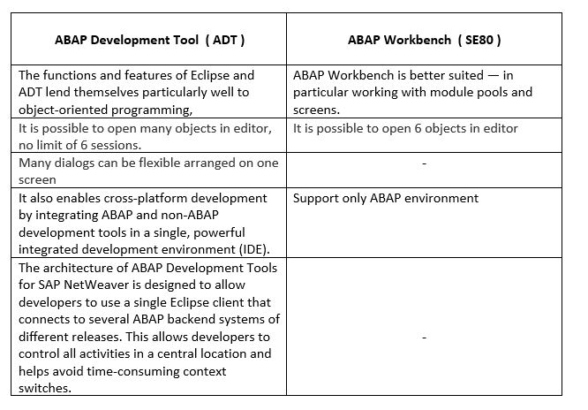

Q: **How do you create a new ABAP project in SAP ADT?**

A: To create a new ABAP project in SAP ADT, follow these steps:

1. Open the SAP Development perspective in Eclipse.
2. Right-click on the ABAP Development node in the Project Explorer and select New > ABAP Project.
3. Enter a name and description for the project, and select the system and client where the project will be created.
4. Select the package where the project will be saved and specify any additional project settings.
5. Click Finish to create the project.

Q: **How do you debug an ABAP program in SAP ADT?**

A: To debug an ABAP program in SAP ADT, follow these steps:

1. Open the ABAP Development perspective in Eclipse.
2. Navigate to the program you want to debug in the Object Navigator.
3. Set a breakpoint in the program by double-clicking on the line of code where you want to pause the program.
4. Execute the program in debug mode by right-clicking on the program and selecting Debug As > ABAP Application.
5. Step through the program line by line using the debug toolbar and inspect variables and objects in the Debug Perspective.